EXPERIMENTS OF NEURAL NETWORKS

NAME-Amandeep
Roll No.- 2301010200
Course- B TECH CSE
Section- C

1.Creates arrays, performs arithmetic operations, demonstrates matrix creation, and shows transpose operation using NumPy numerical computing library.


import numpy as np
# Create arrays
a = np.array([1, 2, 3, 4])
b = np.array([5, 6, 7, 8])
# Operations
print("Array A:", a)
print("Array B:", b)
print("Addition:", a + b)
print("Multiplication:", a * b)
# Matrix
matrix = np.array([[1, 2], [3, 4]])
print("Matrix:\n", matrix)
print("Transpose:\n", matrix.T)
OUTPUT-
Array A: [1 2 3 4]
Array B: [5 6 7 8]
Addition: [ 6 8 10 12]
Multiplication: [ 5 12 21 32]
Matrix:
[[1 2]
[3 4]]
Transpose:
[[1 3]
[2 4]]

2. Creates a DataFrame from dictionary data and calculates mean values using Pandas data analysis library.

import pandas as pd
data = {
"Name": ["Aman", "Ravi", "Priya"],
"Marks": [85, 90, 88]
}
df = pd.DataFrame(data)

print("DataFrame:")
print(df)
print("Mean Marks:", df["Marks"].mean())

OUTPUT-DataFrame:
Name Marks
0 Aman 85
1 Ravi 90
2 Priya 88
Mean Marks: 87.66666666666667

3. Uses SciPy integration function to compute definite integral of a mathematical function within specified limits.

from scipy import integrate

# Define function
def f(x):
return x**2
# Integration
result, error = integrate.quad(f, 0, 2)
print("Integration Result:", result)

OUTPUT-Integration Result: 2.666666666666667

4.Plots a simple quadratic graph using Matplotlib to visualize relationship between input values and output values.

import matplotlib.pyplot as plt
import numpy as np
x = np.linspace(0, 10, 100)
y = x**2
plt.plot(x, y)
plt.title("Simple Plot")
plt.xlabel("X-axis")
plt.ylabel("Y-axis")
plt.show()

OUTPUT-

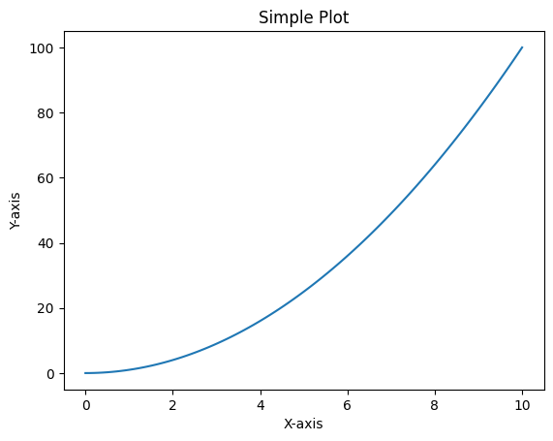
5.Implements a Perceptron model to learn logical AND gate behavior using supervised learning classification method.

from sklearn.linear_model import Perceptron
# AND Gate Data
X = [[0,0],[0,1],[1,0],[1,1]]
y = [0,0,0,1]
model = Perceptron()
model.fit(X, y)
print("Prediction:", model.predict([[1,1]]))

OUTPUT-Prediction: [1]

6. Uses Multi-Layer Perceptron to solve XOR problem, which cannot be solved using single-layer perceptron model.

from sklearn.neural_network import MLPClassifier
X = [[0,0],[0,1],[1,0],[1,1]]
y = [0,1,1,0]
model = MLPClassifier(hidden_layer_sizes=(2,), max_iter=1000)
model.fit(X, y)

print("XOR Predictions:")
print(model.predict(X))

OUTPUT - XOR Predictions:
[0 1 1 1]
/usr/local/lib/python3.12/dist-packages/sklearn/neural_network/_multilayer_perceptron.py:691: ConvergenceWarning: Stochastic Optimizer: Maximum iterations (1000) reached and the optimization hasn't converged yet.
warnings.warn(

7. Plots common activation functions including Sigmoid, Tanh, and ReLU to visualize their output response to input values.
import numpy as np
import matplotlib.pyplot as plt
x = np.linspace(-10, 10, 100)
# Functions
sigmoid = 1/(1 + np.exp(-x))
tanh = np.tanh(x)
relu = np.maximum(0, x)
plt.plot(x, sigmoid, label="Sigmoid")
plt.plot(x, tanh, label="Tanh")
plt.plot(x, relu, label="ReLU")
plt.legend()
plt.title("Activation Functions")
plt.show() OUTPUT -

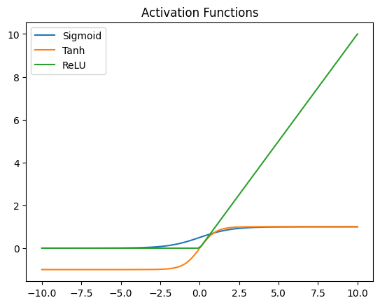
8. Implements a Multi-Layer Perceptron neural network model with hidden layers to perform nonlinear classification tasks.

from sklearn.neural_network import MLPClassifier

X = [[0,0],[0,1],[1,0],[1,1]]
y = [0,1,1,0]
mlp = MLPClassifier(
hidden_layer_sizes=(5,),
activation='relu',
max_iter=2000
)
mlp.fit(X, y)
print("MLP Predictions:")
print(mlp.predict(X))

OUTPUT - MLP Predictions:
[0 1 1 0]

9. Builds neural network model using Adam optimizer to minimize loss and improve learning performance during training iterations.
import numpy as np

# 1. Your original data (lists)
X = [[0, 0], [0, 1], [1, 0], [1, 1]]
y = [0, 1, 1, 0]
# 2. Convert them to NumPy arrays (The Fix)
X = np.array(X)
y = np.array(y)
# 3. Now the model will accept them
model.fit(X, y, epochs=100, verbose=0)
print("Training Complete")

OUTPUT - Training Complete

10. Creates CNN architecture using convolution and pooling layers to extract spatial features from image input data.
import tensorflow as tf
from tensorflow.keras import layers, models
model = models.Sequential([
layers.Conv2D(32, (3,3), activation='relu',
input_shape=(28,28,1)),
layers.MaxPooling2D((2,2)),
layers.Conv2D(64, (3,3), activation='relu'),
layers.MaxPooling2D((2,2)),
layers.Flatten(),
layers.Dense(64, activation='relu'),
layers.Dense(10, activation='softmax')
])
model.compile(
optimizer='adam',
loss='sparse_categorical_crossentropy',
metrics=['accuracy']
)
print("CNN Model Created")

OUTPUT - CNN Model Created

11. Implements SimpleRNN layer to process sequential input data and capture time-dependent patterns in sequences.
import tensorflow as tf
from tensorflow.keras.models import Sequential
from tensorflow.keras.layers import SimpleRNN, Dense
model = Sequential([
SimpleRNN(50, input_shape=(10,1)),
Dense(1)
])
model.compile(
optimizer='adam',
loss='mse'

)
print("RNN Model Created")

OUTPUT- RNN Model Created
/usr/local/lib/python3.12/dist-packages/keras/src/layers/rnn/rnn.py:199: UserWarning: Do not pass an `input_shape`/`input_dim` argument to a layer. When using Sequential models, prefer using an `Input(shape)` object as the first layer in the model instead.
super().__init__(**kwargs)

12. Implements Hopfield network to store patterns and recall stored memory using weighted associative neural network connections.
import numpy as np

# Patterns
patterns = np.array([
[1, -1, 1],
[-1, 1, -1]
])
# Weight matrix
W = np.zeros((3,3))
for p in patterns:
W += np.outer(p, p)
np.fill_diagonal(W, 0)
print("Weight Matrix:\n", W)
# Recall
test = np.array([1, -1, 1])
output = np.sign(W @ test)
print("Recalled Pattern:", output)

OUTPUT- Weight Matrix:
[[ 0. -2. 2.]
[-2. 0. -2.]
[ 2. -2. 0.]]

Recalled Pattern: [ 1. -1. 1.]

